Apollo Lead Generation & Outreach Automation

Project Overview
An automated outbound lead generation system built with n8n, Apollo, Apify, Google Sheets, and Zoho CRM.
The system collects targeted leads, enriches their profiles, validates the data, creates personalized outreach sequences, and syncs qualified leads with the CRM.

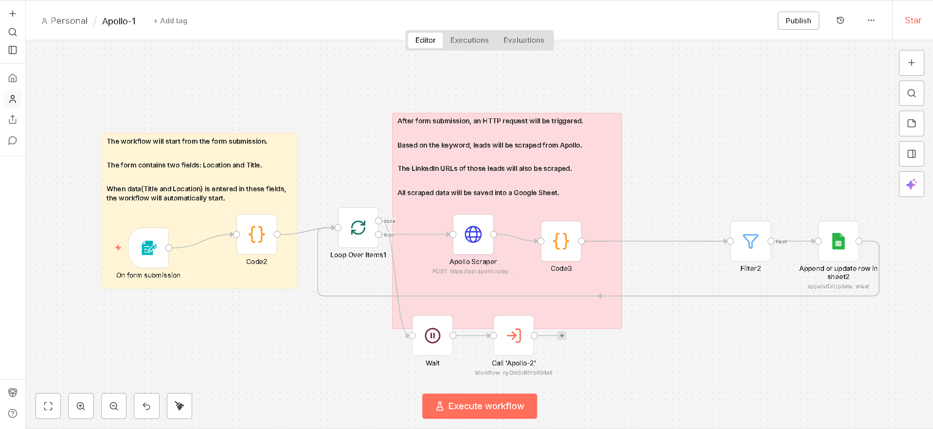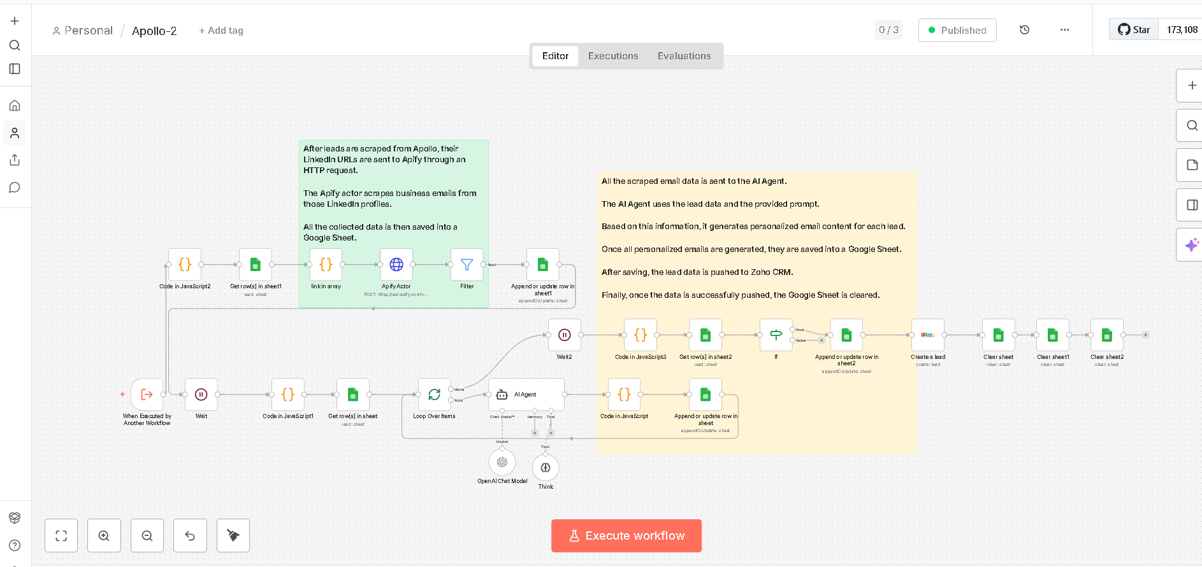

Workflow 1: Lead Discovery
The process starts with a simple form where the user enters the target job title and location.
The workflow then:
• Searches Apollo using the selected criteria
• Processes multiple pages of results
• Extracts lead names, job titles, and LinkedIn profiles
• Removes leads without LinkedIn profiles
• Stores qualified leads in Google Sheets
• Prevents duplicate records using the LinkedIn URL
• Automatically starts the enrichment workflow when complete

Workflow 2: Lead Enrichment & CRM
The second workflow takes the collected LinkedIn profiles and enriches the lead data through Apify.
It then:
• Retrieves additional contact and company information
• Validates business email, name, company, size, and location
• Removes incomplete records
• Stores qualified leads in Google Sheets
• Creates a personalized five email outreach sequence
• Structures the email content for CRM use
• Pushes complete lead records into Zoho CRM
• Clears temporary data after successful completion

CRM Data
Each qualified lead is added to Zoho CRM with:
• Name
• Company
• Email
• Industry
• Job Title
• Company Size
• Company Location
• Initial Email
• Follow Up Emails
• Email Subjects

Workflow
User Input
↓
Apollo Search
↓
Lead Collection
↓
LinkedIn Validation
↓
Google Sheets
↓
Profile Enrichment
↓
Lead Validation
↓
Personalized Outreach
↓
Zoho CRM
↓
Data Cleanup

Key Features
• Automated lead discovery
• Multi page Apollo searches
• LinkedIn profile enrichment
• Lead validation
• Duplicate prevention
• Personalized email sequences
• Google Sheets integration
• Zoho CRM integration
• Batch processing
• Automated data cleanup

Result
A complete outbound prospecting system that moves leads from Apollo search to enriched CRM records and ready to use outreach with minimal manual work.

